**2022**

**Year 7 Science**

**‘Classifications’**

**Revision Booklet**

**Name:**

**Class:**

**Date:**

**History of Classifications**

**Question 1**

What did Carl Linnaeus introduce?

________________________________________________________________

**Question 2**

Draw the classifications hierarchy and include the stages.

**Question 3**

What is a saying that can help us remember the classification hierarchy?

________________________________________________________________________________________________________________________________

**Question 4**

List the 5 kingdoms and provide an explanation for each of them.

* _______________________________________________________________________________________________________________________________________________________________________________________________________________________________________________________________________________________________________
* _______________________________________________________________________________________________________________________________________________________________________________________________________________________________________________________________________________________________________
* _______________________________________________________________________________________________________________________________________________________________________________________________________________________________________________________________________________________________________
* _______________________________________________________________________________________________________________________________________________________________________________________________________________________________________________________________________________________________________
* _______________________________________________________________________________________________________________________________________________________________________________________________________________________________________________________________________________________________________

**Question 5**

What is a dichotomous key?

________________________________________________________________________________________________________________________________________________________________________________________________________________________________________________________________

**Question 6**

Create a dichotomous key with the following: dog, bird, lizard, fish and frog.

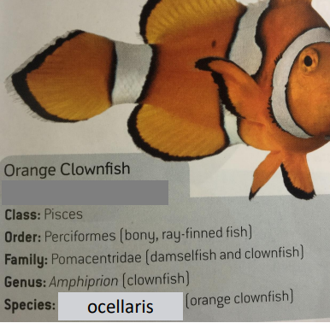**Question 7**

The Linnaeus’s Binomial System is a naming system where the Genus group name always starts with a capital letter and the second word is the species name which does not have a capital letter. What is the Binomial System name for the following?

________________________________________________________________

**Question 8**

Why is it important to find new species and classify them? Provide examples.

________________________________________________________________________________________________________________________________________________________________________________________________

**Question 9**

What is a tabular key?

________________________________________________________________________________________________________________________________

**Question 10**

Create a tabular key with the following: spider, turtle, eagle, beetle and bear.

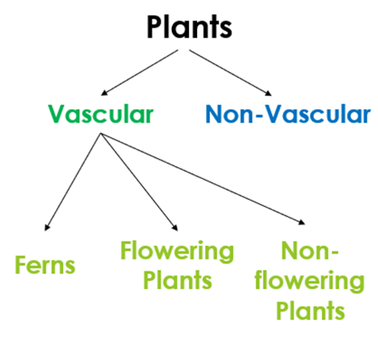

**Question 11**

What are the characteristics of non-vascular plants?

________________________________________________________________________________________________________________________________________________________________________________________________________________________________________________________________________________________________________________________________________________________________________________________________________________________________________________________________

**Question 12**

What are the characteristics of vascular plants?

________________________________________________________________________________________________________________________________________________________________________________________________________________________________________________________________________________________________________________________________________________________________________________________________________________________________________________________________

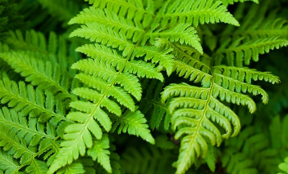**Question 13**

What are the characteristics of ferns (vascular plants)?

________________________________________________________________________________________________________________________________________________________________________________________________________________________________________________________________________________________________________________________________________________________________________________________________________________________________________________________________

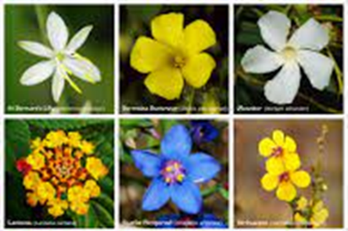**Question 14**

What are the characteristics of flowering plants (vascular plants)?

________________________________________________________________________________________________________________________________________________________________________________________________________________________________________________________________________________________________________________________________________________________________________________________________________________________________________________________________

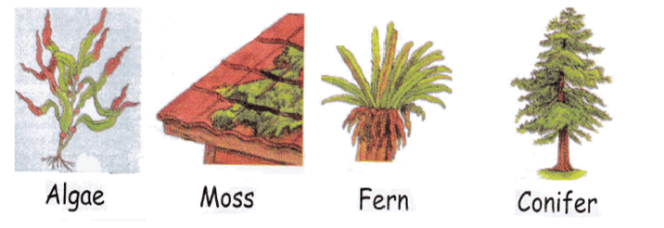**Question 15**

What are the characteristics of non-flowering plants (vascular plants)?

________________________________________________________________________________________________________________________________________________________________________________________________________________________________________________________________________________________________________________________________________________________________________________________________________________________________________________________________

**Question 16**

Living things must possess 8 different criteria’s, what are these?

* ___________________________________________________________
* ___________________________________________________________
* ___________________________________________________________
* ___________________________________________________________
* ___________________________________________________________
* ___________________________________________________________
* ___________________________________________________________
* ___________________________________________________________

**Question 17**

What is an acronym that can help us remember these 8 criteria’s?

________________________________________________________________

**Question 18**

The words below are characteristics of Kingdom Animalia, define these words:

Multicellular: ________________________________________________________________________________________________________________________________

Heterotrophs: ________________________________________________________________________________________________________________________________

Motile: ________________________________________________________________________________________________________________________________

Non-Motile: ________________________________________________________________________________________________________________________________

Eukaryotes: ________________________________________________________________________________________________________________________________

**Question 19**

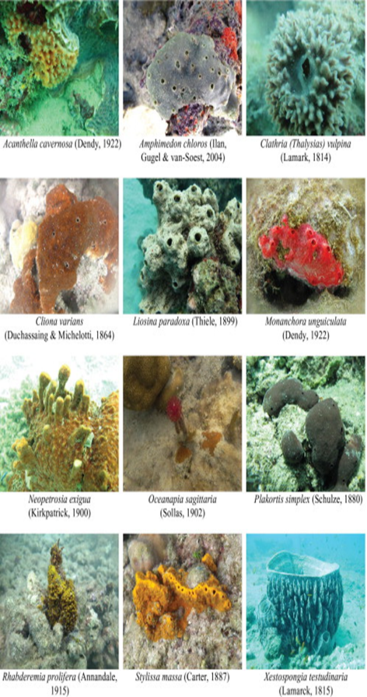There are many Phylum’s within Kingdom Animalia, provide the characteristics for the following Phylum’s and provide examples:

Poriferans:

______________________________________________

______________________________________________

________________________________________________________________

________________________________________________________________

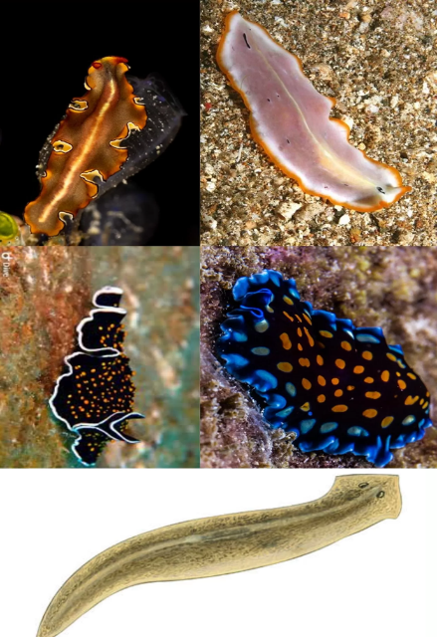Platyhelminthes:

______________________________________________

______________________________________________

______________________________________________

______________________________________________

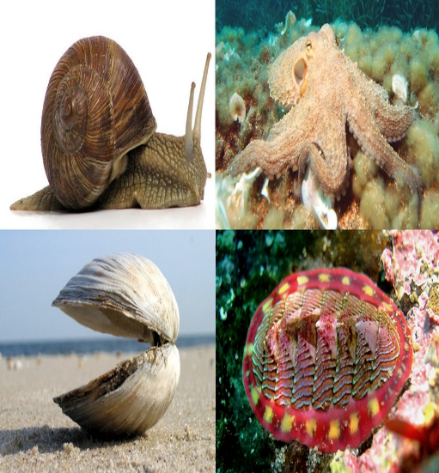Molluscs:

______________________________________________

______________________________________________

______________________________________________

______________________________________________

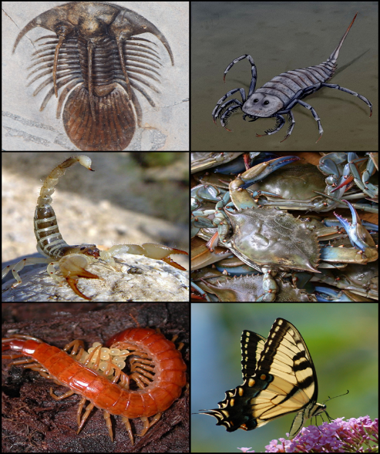Arthropods:

______________________________________________

______________________________________________

______________________________________________

­­­­______________________________________________

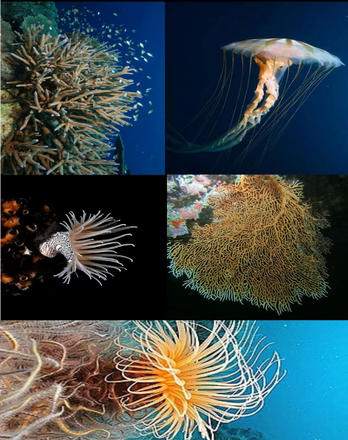Cnidarians:

______________________________________________

______________________________________________

______________________________________________

­­­­______________________________________________

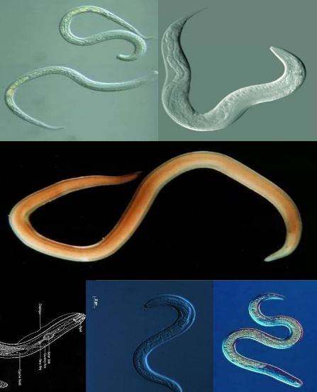Nematodes:

______________________________________________

______________________________________________

______________________________________________

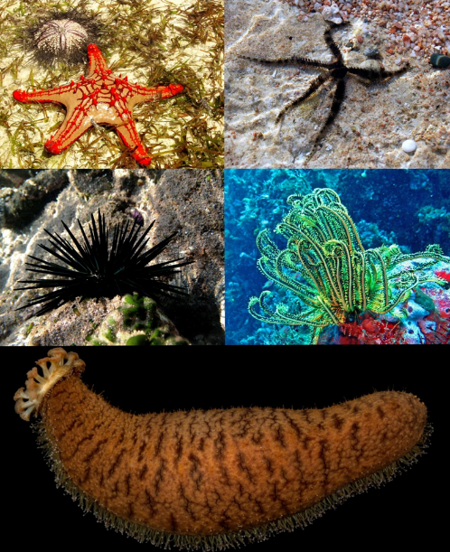­­­­______________________________________________

Echinoderms:

______________________________________________

______________________________________________

______________________________________________

­­­­______________________________________________

Chordates:

______________________________________________

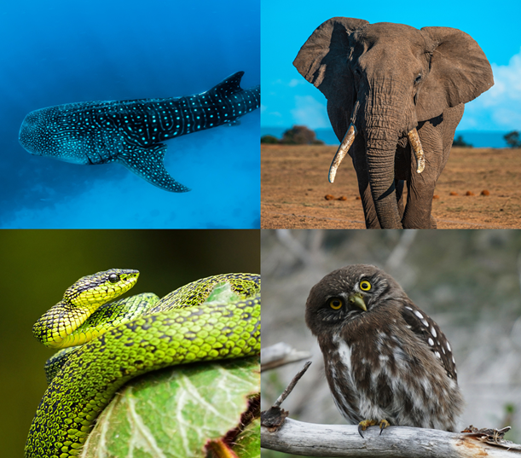______________________________________________

______________________________________________

­­­­______________________________________________

______________________________________________

______________________________________________

**Question 20**

What are invertebrates?

________________________________________________________________________________________________________________________________________________________________________________________________

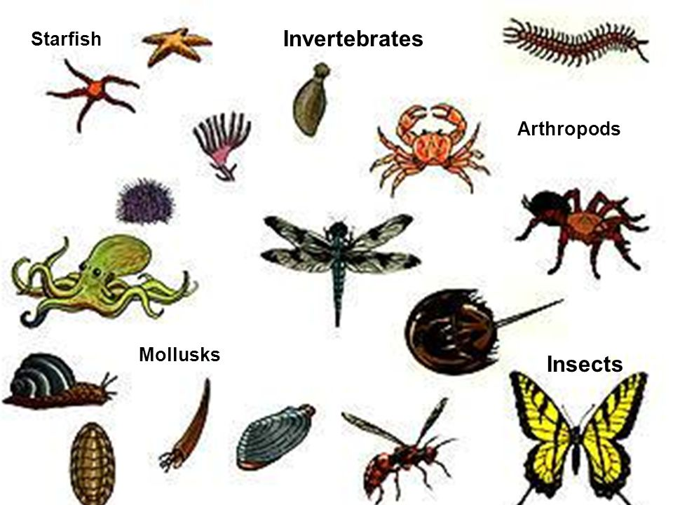________________________________________________________________

**Question 21**

What are vertebrates?

________________________________________________________________________________________________________________________________________________________________________________________________

________________________________________________________________

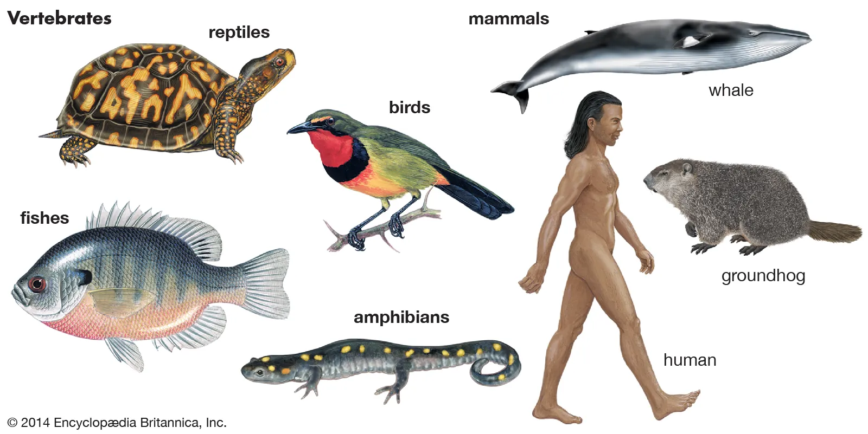

**Question 22**

Within vertebrates there are 5 classes: Pisces, Amphibian, Reptilia, Aves and Mammalia. Provide a description of their characteristics and provide examples.

Class Mammalia:

________________________________________________________________________________________________________________________________________________________________________________________________

________________________________________________________________

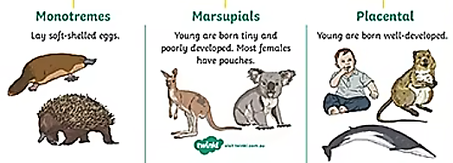

Class Aves:

________________________________________________________________________________________________________________________________________________________________________________________________

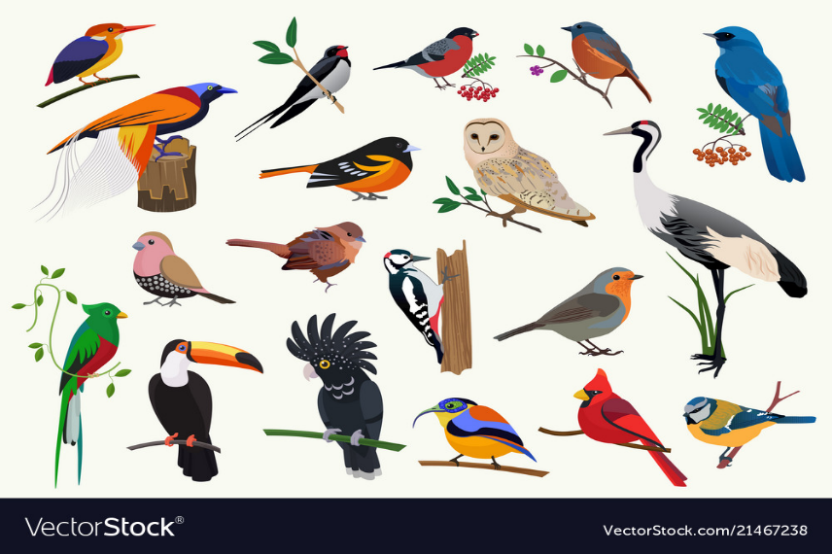________________________________________________________________

Class Reptilia:

________________________________________________________________________________________________________________________________________________________________________________________________

________________________________________________________________

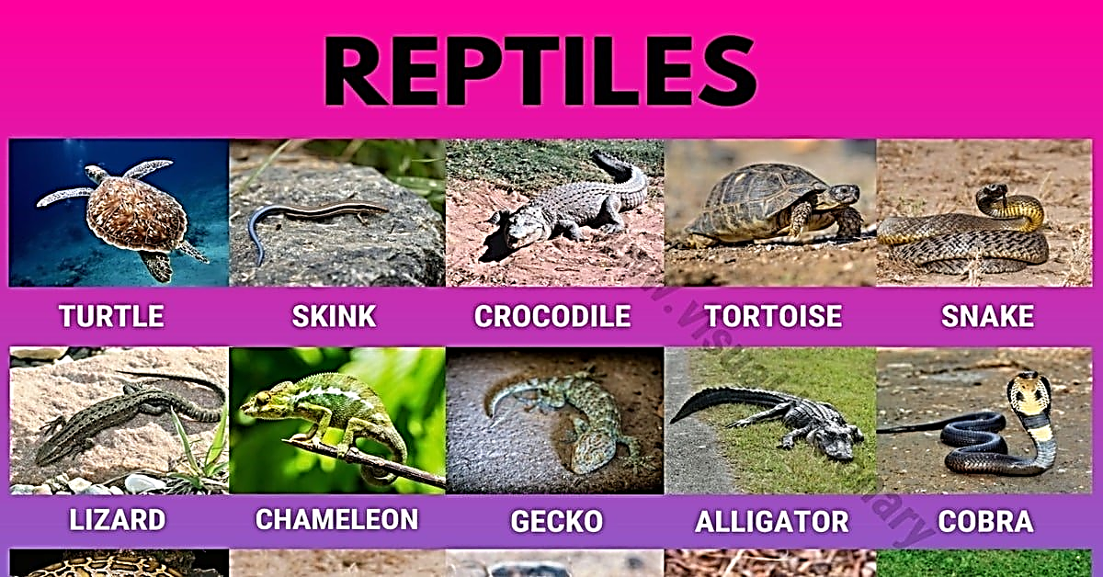

Class Amphibia:

________________________________________________________________________________________________________________________________________________________________________________________________

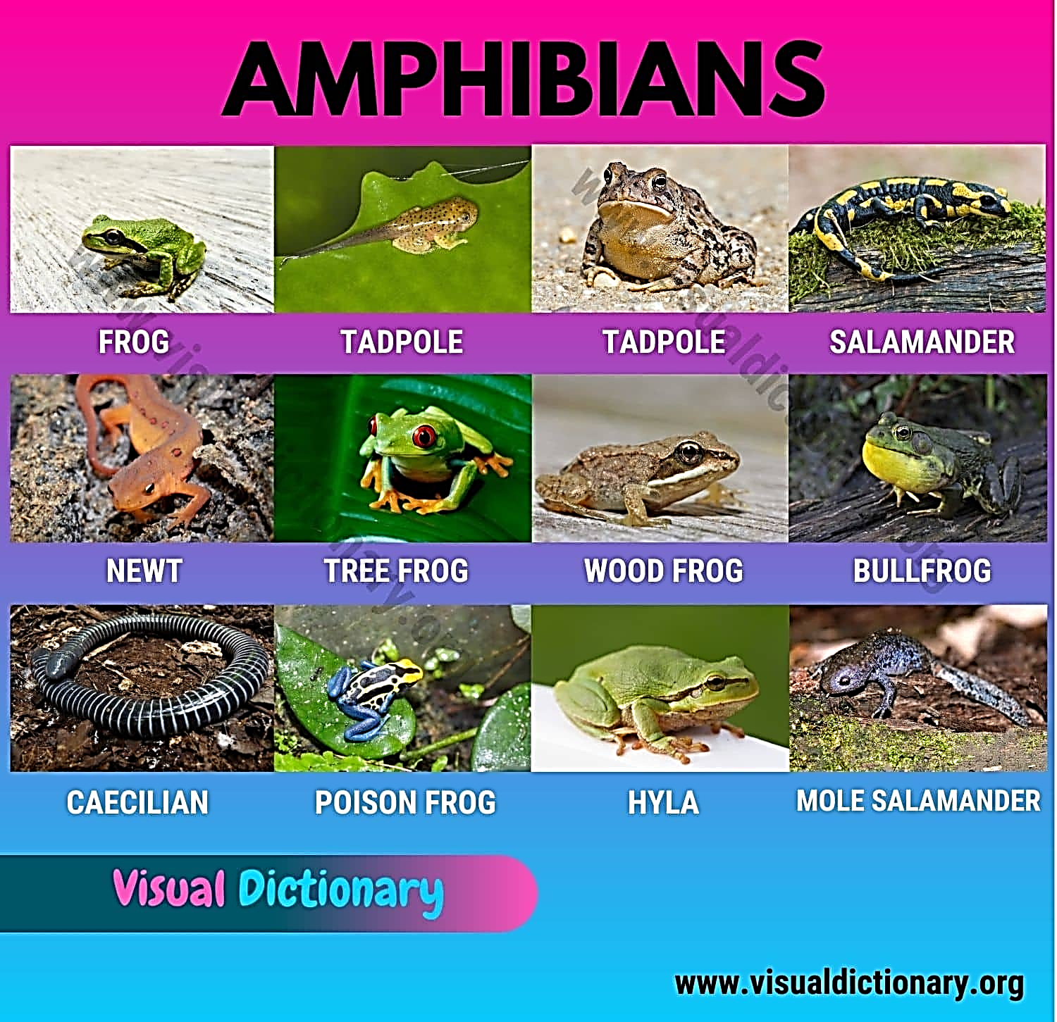________________________________________________________________

Class Pisces:

________________________________________________________________________________________________________________________________________________________________________________________________

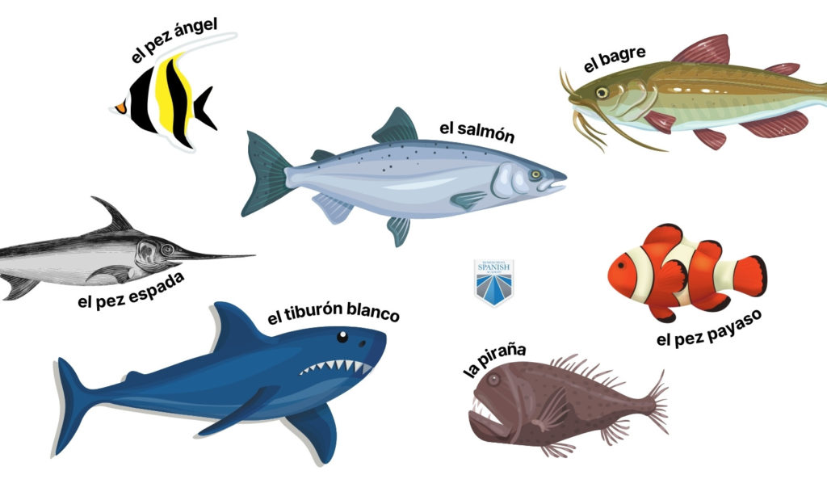________________________________________________________________

**Additional Notes:**

**________________________________________________________________________________________________________________________________________________________________________________________________________________________________________________________________________________________________________________________________________________________________________________________________**